**Introduction to Decision Tree Algorithm**

Decision Tree algorithm belongs to the family of [supervised learning algorithms](https://dataaspirant.com/2014/09/19/supervised-and-unsupervised-learning/). Unlike other supervised learning algorithms, decision tree algorithm can be used for solving [**regression and classification**](https://dataaspirant.com/2014/09/27/classification-and-prediction/) **problems** too.

The general motive of using Decision Tree is to create a training model which can use to predict class or value of target variables by **learning decision rules** inferred from prior data(training data).

The understanding level of Decision Trees algorithm is so easy compared with other classification algorithms. The decision tree algorithm tries to solve the problem, by using tree representation. Each **internal node** of the tree corresponds to an attribute, and each **leaf node** corresponds to a class label.

**Decision Tree Algorithm Pseudocode**

1. Place the best attribute of the dataset at the **root** of the tree.
2. Split the training set into **subsets**. Subsets should be made in such a way that each subset contains data with the same value for an attribute.
3. Repeat step 1 and step 2 on each subset until you find **leaf nodes** in all the branches of the tree.

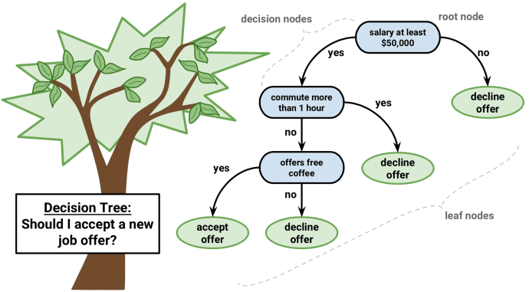

Decision Tree classifier, **Image credit:** www.packtpub.com

In decision trees, for predicting a class label for a record we start from the **root** of the tree. We compare the values of the root attribute with record’s attribute. On the basis of comparison, we follow the branch corresponding to that value and jump to the next node.

We continue comparing our record’s attribute values with other **internal nodes** of the tree until we reach **a leaf node** with predicted class value. As we know how the modeled decision tree can be used to predict the target class or the value. Now let’s understanding how we can create the decision tree model.

**Assumptions while creating Decision Tree**

The below are the some of the assumptions we make while using Decision tree:

* At the beginning, the whole training set is considered as the **root.**
* Feature values are preferred to be categorical. If the values are continuous then they are discretized prior to building the model.
* Records are **distributed recursively** on the basis of attribute values.
* Order to placing attributes as root or internal node of the tree is done by using some statistical approach.

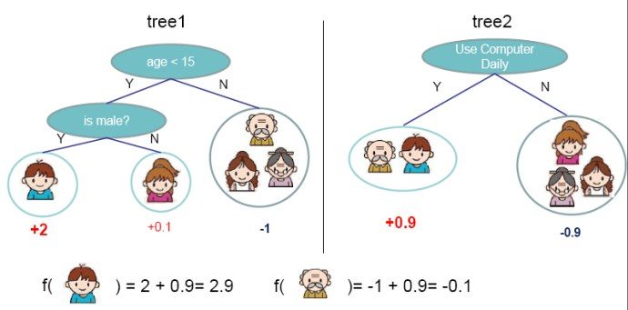

Decision tree model example Image Credit: **http://zhanpengfang.github.io/**

Decision Trees follow **Sum of Product (SOP)** representation. For the above images, you can see how we can predict **can** **we accept the new job offer?  and Use computer daily?**from traversing for the root node to the leaf node.

It’s a sum of product representation. The Sum of product(SOP) is also known as **Disjunctive Normal Form**. For a class, every branch from the root of the tree to a leaf node having the same class is a conjunction(product) of values, different branches ending in that class form a disjunction(sum).

The primary challenge in the decision tree implementation is to identify which attributes do we need to consider as the root node and each level. Handling this is know the attributes selection. We have different attributes selection measure to identify the attribute which can be considered as the root note at each level.

**The popular attribute selection measures:**

* Information gain
* Gini index

**Attributes Selection**

If dataset consists of **“n”** attributes then deciding which attribute to place at the root or at different levels of the tree as internal nodes is a complicated step. By just randomly selecting any node to be the root can’t solve the issue. If we follow a random approach, it may give us bad results with low accuracy.

For solving this attribute selection problem, researchers worked and devised some solutions. They suggested using some *criterion* like **information gain, gini index,** etc. These criterions will calculate values for every attribute. The values are sorted, and attributes are placed in the tree by following the order i.e, the attribute with a high value(in case of information gain) is placed at the root.

While using information Gain as a criterion, we assume attributes to be categorical, and for gini index, attributes are assumed to be continuous.

**Information Gain**

By using information gain as a criterion, we try to estimate the information contained by each attribute. We are going to use some points deducted from [information theory](https://en.wikipedia.org/wiki/Information_theory).  
To measure the randomness or uncertainty of a random variable X is defined by **Entropy**.

For a binary classification problem with only two classes, positive and negative class.

* If all examples are positive or all are negative then entropy will be zero i.e, low.
* If half of the records are of positive class and half are of negative class then entropy is one i.e, high.

By calculating **entropy measure** of each attribute we can calculate their **information gain**. Information Gain calculates the expected reduction in entropy due to sorting on the attribute. Information gain can be calculated.

To get a clear understanding of calculating **information gain & entropy**, we will try to implement it on a sample data.

**Example: Construct a Decision Tree by using “information gain” as a criterion**

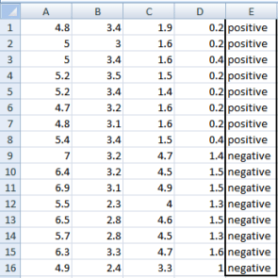We are going to use this data sample. Let’s try to use information gain as a criterion. Here, we have 5 columns out of which 4 columns have continuous data and 5th column consists of class labels.

A, B, C, D attributes can be considered as predictors and E column class labels can be considered as a target variable. For constructing a decision tree from this data, we have to convert continuous data into categorical data.

We have chosen some random values to categorize each attribute:

|  |  |  |  |
| --- | --- | --- | --- |
| **A** | **B** | **C** | **D** |
| >= 5 | >= 3.0 | >= 4.2 | >= 1.4 |
| < 5 | < 3.0 | < 4.2 | < 1.4 |

There are **2 steps for calculating information gain** for each attribute:

1. Calculate entropy of Target.
2. Entropy for every attribute A, B, C, D needs to be calculated. Using information gain formula we will subtract this entropy from the entropy of target. The result is Information Gain.

**The entropy of Target:** We have 8 records with negative class and 8 records with positive class. So, we can directly estimate the entropy of target as 1.

|  |  |
| --- | --- |
| Variable E | |
| Positive | Negative |
| 8 | 8 |

**Calculating entropy using formula:**

E(8,8) = -1*( (p(+ve)*log( p(+ve)) + (p(-ve)*log( p(-ve)) )  
= -1*( (8/16)*log2(8/16)) + (8/16) * log2(8/16) )  
= 1

**Information gain for Var A**

Var A has value >=5 for 12 records out of 16 and 4 records with value <5 value.

* For Var A >= 5 & class == positive: 5/12
* For Var A >= 5 & class == negative: 7/12
  + Entropy(5,7) = -1 * ( (5/12)*log2(5/12) + (7/12)*log2(7/12)) = 0.9799
* For Var A <5 & class == positive: 3/4
* For Var A <5 & class == negative: 1/4
  + Entropy(3,1) =  -1 * ( (3/4)*log2(3/4) + (1/4)*log2(1/4)) = 0.81128

Entropy(Target, A) = P(>=5) * E(5,7) + P(<5) * E(3,1)  
= (12/16) * 0.9799 + (4/16) * 0.81128 = 0.937745

\textrm{Information Gain(IG) = E(Target) - E(Target,A) = 1- 0.9337745 = 0.062255}  

**Information gain for Var B**

Var B has value >=3 for 12 records out of 16 and 4 records with value <5 value.

* For Var B >= 3 & class == positive: 8/12
* For Var B >= 3 & class == negative: 4/12
  + Entropy(8,4) = -1 * ( (8/12)*log2(8/12) + (4/12)*log2(4/12)) = 0.39054
* For VarB <3 & class == positive: 0/4
* For Var B <3 & class == negative: 4/4
  + Entropy(0,4) =  -1 * ( (0/4)*log2(0/4) + (4/4)*log2(4/4)) = 0

Entropy(Target, B) = P(>=3) * E(8,4) + P(<3) * E(0,4)  
= (12/16) * 0.39054 + (4/16) * 0 = 0.292905

\textrm{Information Gain(IG) = E(Target) - E(Target,B) = 1- 0.292905= 0.707095}  

**Information gain for Var C**

Var C has value >=4.2 for 6 records out of 16 and 10 records with value <4.2 value.

* For Var C >= 4.2 & class == positive: 0/6
* For Var C >= 4.2 & class == negative:  6/6
  + Entropy(0,6) = 0
* For VarC < 4.2 & class == positive: 8/10
* For Var C < 4.2 & class == negative: 2/10
  + Entropy(8,2) = 0.72193

Entropy(Target, C) = P(>=4.2) * E(0,6) + P(< 4.2) * E(8,2)  
= (6/16) * 0 + (10/16) * 0.72193 = 0.4512

\textrm{Information Gain(IG) = E(Target) - E(Target,C) = 1- 0.4512= 0.5488}  

**Information gain for Var D**

Var D has value >=1.4 for 5 records out of 16 and 11 records with value <5 value.

* For Var D >= 1.4 & class == positive: 0/5
* For Var D >= 1.4 & class == negative: 5/5
  + Entropy(0,5) = 0
* For Var D < 1.4 & class == positive: 8/11
* For Var D < 14 & class == negative: 3/11
  + Entropy(8,3) =  -1 * ( (8/11)*log2(8/11) + (3/11)*log2(3/11)) = 0.84532

Entropy(Target, D) = P(>=1.4) * E(0,5) + P(< 1.4) * E(8,3)  
= 5/16 * 0 + (11/16) * 0.84532 = 0.5811575

\textrm{Information Gain(IG) = E(Target) - E(Target,D) = 1- 0.5811575 = 0.41189}  

|  |  |  |  |  |  |  |  |  |  |  |  |  |  |  |  |  |  |  |  |  |  |  |  |  |  |  |  |  |  |  |  |  |  |  |  |
| --- | --- | --- | --- | --- | --- | --- | --- | --- | --- | --- | --- | --- | --- | --- | --- | --- | --- | --- | --- | --- | --- | --- | --- | --- | --- | --- | --- | --- | --- | --- | --- | --- | --- | --- | --- |
| |  |  |  |  | | --- | --- | --- | --- | |  | | **Target** | | | Positive | Negative | | A | >= 5.0 | 5 | 7 | | <5 | 3 | 1 | | Information Gain of A = 0.062255 | | | | | |  |  |  |  | | --- | --- | --- | --- | |  | | **Target** | | | Positive | Negative | | B | >= 3.0 | 8 | 4 | | < 3.0 | 0 | 4 | | Information Gain of B= 0.7070795 | | | | |
| |  |  |  |  | | --- | --- | --- | --- | |  | | **Target** | | | Positive | Negative | | C | >= 4.2 | 0 | 6 | | < 4.2 | 8 | 2 | | Information Gain of C= 0.5488 | | | | | |  |  |  |  | | --- | --- | --- | --- | |  | | **Target** | | | Positive | Negative | | D | >= 1.4 | 0 | 5 | | < 1.4 | 8 | 3 | | Information Gain of D= 0.41189 | | | | |

From the above Information Gain calculations, we can build a decision tree. We should place the attributes on the tree according to their values.

An Attribute with better value than other should position as root and A branch with entropy 0 should be converted to a leaf node. A branch with entropy more than 0 needs further splitting.

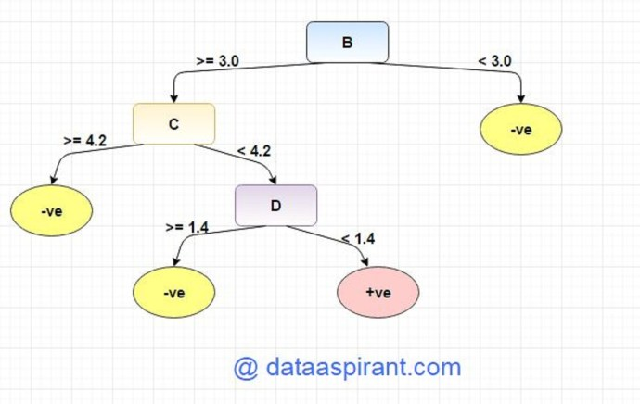

**Gini Index**

Gini Index is a metric to measure how often a randomly chosen element would be incorrectly identified. It means an attribute with lower gini index should be preferred.

**Example: Construct a Decision Tree by using “gini index” as a criterion**

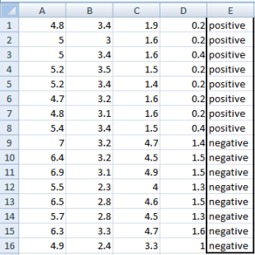We are going to use same data sample that we used for information gain example. Let’s try to use gini index as a criterion. Here, we have 5 columns out of which 4 columns have continuous data and 5th column consists of class labels.

A, B, C, D attributes can be considered as predictors and E column class labels can be considered as a target variable. For constructing a decision tree from this data, we have to convert continuous data into categorical data.

We have chosen some random values to categorize each attribute:

|  |  |  |  |
| --- | --- | --- | --- |
| **A** | **B** | **C** | **D** |
| >= 5 | >= 3.0 | >=4.2 | >= 1.4 |
| < 5 | < 3.0 | < 4.2 | < 1.4 |

Gini Index

**Gini Index for Var A**

Var A has value >=5 for 12 records out of 16 and 4 records with value <5 value.

* For Var A >= 5 & class == positive: 5/12
* For Var A >= 5 & class == negative: 7/12
  + gini(5,7) = 1- ( (5/12)2 + (7/12)2 ) = 0.4860
* For Var A <5 & class == positive: 3/4
* For Var A <5 & class == negative: 1/4
  + gini(3,1) = 1- ( (3/4)2 + (1/4)2 ) = 0.375

By adding weight and sum each of the gini indices:

\textrm{gini(Target, A) = (12/16) * (0.486) + (4/16) * (0.375) = 0.45825}

**Gini Index for Var B**

Var B has value >=3 for 12 records out of 16 and 4 records with value <5 value.

* For Var B >= 3 & class == positive: 8/12
* For Var B >= 3 & class == negative: 4/12
  + gini(8,4) = 1- ( (8/12)2 + (4/12)2 ) = 0.446
* For Var B <3 & class == positive: 0/4
* For Var B <3 & class == negative: 4/4
  + gin(0,4) = 1- ( (0/4)2 + (4/4)2 ) = 0

\textrm{gini(Target, B) = (12/16) * 0.446 + (4/16) * 0 = 0.3345}

**Gini Index for Var C**

Var C has value >=4.2 for 6 records out of 16 and 10 records with value <4.2 value.

* For Var C >= 4.2 & class == positive: 0/6
* For Var C >= 4.2 & class == negative: 6/6
  + gini(0,6) = 1- ( (0/8)2 + (6/6)2 ) = 0
* For Var C < 4.2& class == positive: 8/10
* For Var C < 4.2 & class == negative: 2/10
  + gin(8,2) = 1- ( (8/10)2 + (2/10)2 ) = 0.32

\textrm{gini(Target, C) = (6/16) * 0+ (10/16) * 0.32 = 0.2} 

**Gini Index for Var D**

Var D has value >=1.4 for 5 records out of 16 and 11 records with value <1.4 value.

* For Var D >= 1.4 & class == positive: 0/5
* For Var D >= 1.4 & class == negative: 5/5
  + gini(0,5) = 1- ( (0/5)2 + (5/5)2 ) = 0
* For Var D < 1.4 & class == positive: 8/11
* For Var D < 1.4 & class == negative: 3/11
  + gin(8,3) = 1- ( (8/11)2 + (3/11)2 ) = 0.397

\textrm{ gini(Target, D) = (5/16) * 0+ (11/16) * 0.397 = 0.273} 

|  |  |  |  |  |  |  |  |  |  |  |  |  |  |  |  |  |  |  |  |  |  |  |  |  |  |  |  |  |  |  |  |  |  |  |  |
| --- | --- | --- | --- | --- | --- | --- | --- | --- | --- | --- | --- | --- | --- | --- | --- | --- | --- | --- | --- | --- | --- | --- | --- | --- | --- | --- | --- | --- | --- | --- | --- | --- | --- | --- | --- |
| |  |  |  |  | | --- | --- | --- | --- | |  | | wTarget | | | Positive | Negative | | A | >= 5.0 | 5 | 7 | | <5 | 3 | 1 | | Ginin Index of A = 0.45825 | | | | | |  |  |  |  | | --- | --- | --- | --- | |  | | Target | | | Positive | Negative | | B | >= 3.0 | 8 | 4 | | < 3.0 | 0 | 4 | | Gini Index of B= 0.3345 | | | | |
| |  |  |  |  | | --- | --- | --- | --- | |  | | Target | | | Positive | Negative | | C | >= 4.2 | 0 | 6 | | < 4.2 | 8 | 2 | | Gini Index of C= 0.2 | | | | | |  |  |  |  | | --- | --- | --- | --- | |  | | Target | | | Positive | Negative | | D | >= 1.4 | 0 | 5 | | < 1.4 | 8 | 3 | | Gini Index of D= 0.273 | | | | |

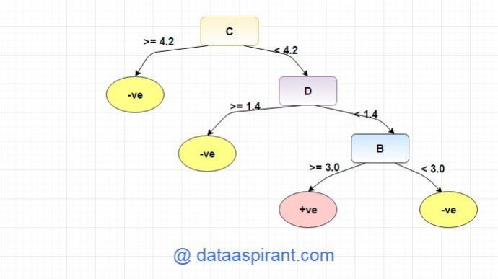

**Overfitting**

Overfitting is a practical problem while building a decision tree model. The model is having an issue of overfitting is considered when the algorithm continues to go deeper and deeper in the to reduce the training set error but results with an increased test set error i.e, Accuracy of prediction for our model goes down. It generally happens when it builds many branches due to outliers and irregularities in data.

Two approaches which we can use to avoid overfitting are:

* Pre-Pruning
* Post-Pruning

**Pre-Pruning**

In pre-pruning, it stops the tree construction bit early. It is preferred not to split a node if its goodness measure is below a threshold value. But it’s difficult to choose an appropriate stopping point.

**Post-Pruning**

In post-pruning first, it goes deeper and deeper in the tree to build a complete tree. If the tree shows the overfitting problem then pruning is done as a post-pruning step. We use a cross-validation data to check the effect of our pruning. Using cross-validation data, it tests whether expanding a node will make an improvement or not.

If it shows an improvement, then we can continue by expanding that node. But if it shows a reduction in accuracy then it should not be expanded i.e, the node should be converted to a leaf node.

**Decision Tree Algorithm Advantages and Disadvantages**

**Advantages:**

1. Decision Trees are easy to explain. It results in a set of rules.
2. It follows the same approach as humans generally follow while making decisions.
3. Interpretation of a complex Decision Tree model can be simplified by its visualizations. Even a naive person can understand logic.
4. The Number of hyper-parameters to be tuned is almost null.

**Disadvantages:**

1. There is a high probability of overfitting in Decision Tree.
2. Generally, it gives low prediction accuracy for a dataset as compared to other machine learning algorithms.
3. Information gain in a decision tree with categorical variables gives a biased response for attributes with greater no. of categories.
4. Calculations can become complex when there are many class labels.

**ANOTHER INTRODUCTION**

|  |  |  |
| --- | --- | --- |
| **Decision Tree - Classification** |  |  |
|  |  |  |
|  |  |  |
| Decision tree builds classification or regression models in the form of a tree structure. It breaks down a dataset into smaller and smaller subsets while at the same time an associated decision tree is incrementally developed. The final result is a tree with **decision nodes** and **leaf nodes**. A decision node (e.g., Outlook) has two or more branches (e.g., Sunny, Overcast and Rainy). Leaf node (e.g., Play) represents a classification or decision. The topmost decision node in a tree which corresponds to the best predictor called **root node**. Decision trees can handle both categorical and numerical data.   |  |  |  | | --- | --- | --- | | https://www.saedsayad.com/images/Decision_Tree_1.png |  |  | |  |  |  | | Algorithm |  |  | | The core algorithm for building decision trees called **ID3** by J. R. Quinlan which employs a top-down, greedy search through the space of possible branches with no backtracking. ID3 uses *Entropy* and *Information Gain* to construct a decision tree. In ZeroR model there is no predictor, in OneR model we try to find the single best predictor, naive Bayesian includes all predictors using Bayes' rule and the independence assumptions between predictors but decision tree includes all predictors with the dependence assumptions between predictors. |  |  | |  |  |  | | **Entropy** |  |  | | A decision tree is built top-down from a root node and involves partitioning the data into subsets that contain instances with similar values (homogenous). ID3 algorithm uses entropy to calculate the homogeneity of a sample. If the sample is completely homogeneous the entropy is zero and if the sample is an equally divided it has entropy of one. |  |  | |  |  |  | | https://www.saedsayad.com/images/Entropy.png |  |  | | To build a decision tree, we need to calculate two types of entropy using frequency tables as follows: |  |  | |  |  |  | | a) Entropy using the frequency table of one attribute: |  |  | | https://www.saedsayad.com/images/Entropy_3.png |  |  | | b) Entropy using the frequency table of two attributes: |  |  | | https://www.saedsayad.com/images/Entropy_2.png |  |  | |  |  |  | | **Information Gain** |  |  | | The information gain is based on the decrease in entropy after a dataset is split on an attribute. Constructing a decision tree is all about finding attribute that returns the highest information gain (i.e., the most homogeneous branches). |  |  | |  |  |  | | *Step 1*: Calculate entropy of the target. |  |  | | https://www.saedsayad.com/images/Entropy_target.png |  |  | | *Step 2*: The dataset is then split on the different attributes. The entropy for each branch is calculated. Then it is added proportionally, to get total entropy for the split. The resulting entropy is subtracted from the entropy before the split. The result is the Information Gain, or decrease in entropy. |  |  | | https://www.saedsayad.com/images/Entropy_attributes.png |  |  | | https://www.saedsayad.com/images/Entropy_gain.png |  |  | | *Step 3*: Choose attribute with the largest information gain as the decision node, divide the dataset by its branches and repeat the same process on every branch. |  |  | | https://www.saedsayad.com/images/Entropy_attribute_best.png |  |  | | https://www.saedsayad.com/images/decision_tree_slices.png |  |  | | *Step 4a*: A branch with entropy of 0 is a leaf node. |  |  | | https://www.saedsayad.com/images/Entropy_overcast.png |  |  | | *Step 4b*: A branch with entropy more than 0 needs further splitting. |  |  | | https://www.saedsayad.com/images/Entropy_Sunny.png |  |  | | *Step 5*: The ID3 algorithm is run recursively on the non-leaf branches, until all data is classified. |  |  | |  |  |  | |  |  |  | | Decision Tree to Decision Rules |  |  | | A decision tree can easily be transformed to a set of rules by mapping from the root node to the leaf nodes one by one. |  |  | | https://www.saedsayad.com/images/Decision_rules.png |  |  | |  |  |